- This week's modest upside surprises for UK private sector pay growth and services inflation, extinguished any remaining hopes of a May rate cut. But the big movement in market pricing in response looks like an overreaction. We still expect a summer rate cut, provided there are no nasty surprises in the key April data for pay and inflation.
- Elsewhere, flat retail sales in March capped off a strong quarter for household spending. With inflation set to fall further, we think rising real incomes point to a much better outlook for retailers this year, provided consumers move away from the very cautious behaviour they exhibited last year.
In its March policy statement, the Bank of England's Monetary Policy Committee stated that further evidence on inflation persistence would be required to warrant a shift in the monetary policy stance and the degree of restrictiveness would be considered at each meeting. With only one set of labour market and inflation data due to be published between the March and May meetings, this week's releases had to surprise on the downside to keep a May rate cut in play.
The first of those, Tuesday's pay data for February, did the opposite. Headline (three-month average of the annual rate) private sector regular pay growth, the BoE's favoured measure, only fell to 6%, from 6.1% in January.
Despite this stronger-than-expected February outturn, the downward momentum in pay growth looks likely to gather pace in the coming months. HMRC's timelier, if revision-prone, flash median measure of employee pay growth fell markedly in March. Moreover, our proprietary sentiment-based wage nowcast, developed in collaboration with Penta, suggests pay growth fell quickly in March and the first half of April (Chart 1). Consistent with these developments, there was also evidence that labour market conditions loosened further – the jobless rate picked up in the three months to February, HMRC's payroll measure of employment fell, meanwhile vacancies drifted lower again.
Chart 1: Our wage indicator suggests pay growth is now cooling sharply
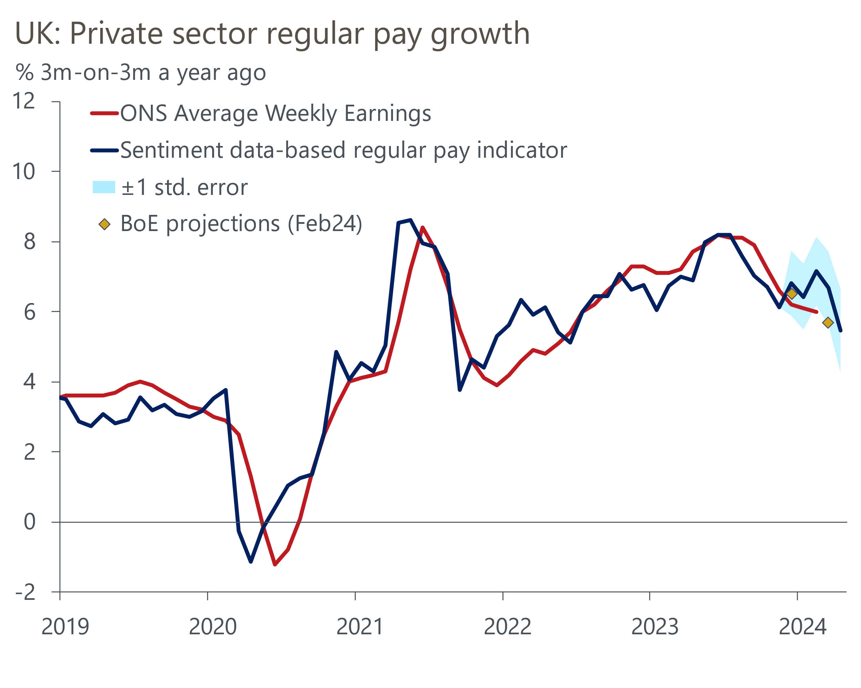
Sources: Oxford Economics, Penta, Haver Analytics

It was a similar story with Wednesday's inflation release. CPI inflation slowed to 3.2% in March, from 3.4% in the previous month. The downshift was due to base effects in the food and core categories, following unusually large rises in these components between February and March last year. This was more than enough to offset the impact of higher petrol prices. However, inflation still came in slightly higher than we and the BoE had expected, with the stickiness of services inflation the key factor behind this.
But there's still a strong chance that CPI inflation will return to the BoE's 2% target in the coming months. April's 12% drop in Ofgem's energy price cap will increase the drag from the energy category. In the same month, core inflation is likely to soften as the annual uprating in many inflation-linked contracts and regulated prices should be smaller than last year. Meanwhile, the ongoing impact of base effects on food prices will lower the contributions from this category.
Though the upside surprises were small, they came on the back of last week's hotter-than-expected US March CPI print. In such a febrile mood, markets reacted aggressively. On Thursday, market pricing implied the first UK rate cut will occur in the autumn, with a little less than two 25bps cuts this year. After the MPC's March meeting just a couple of weeks ago, markets fully priced in three 25bps cuts (Chart 2).
Chart 2: Markets have raised their rate expectations significantly in recent weeks
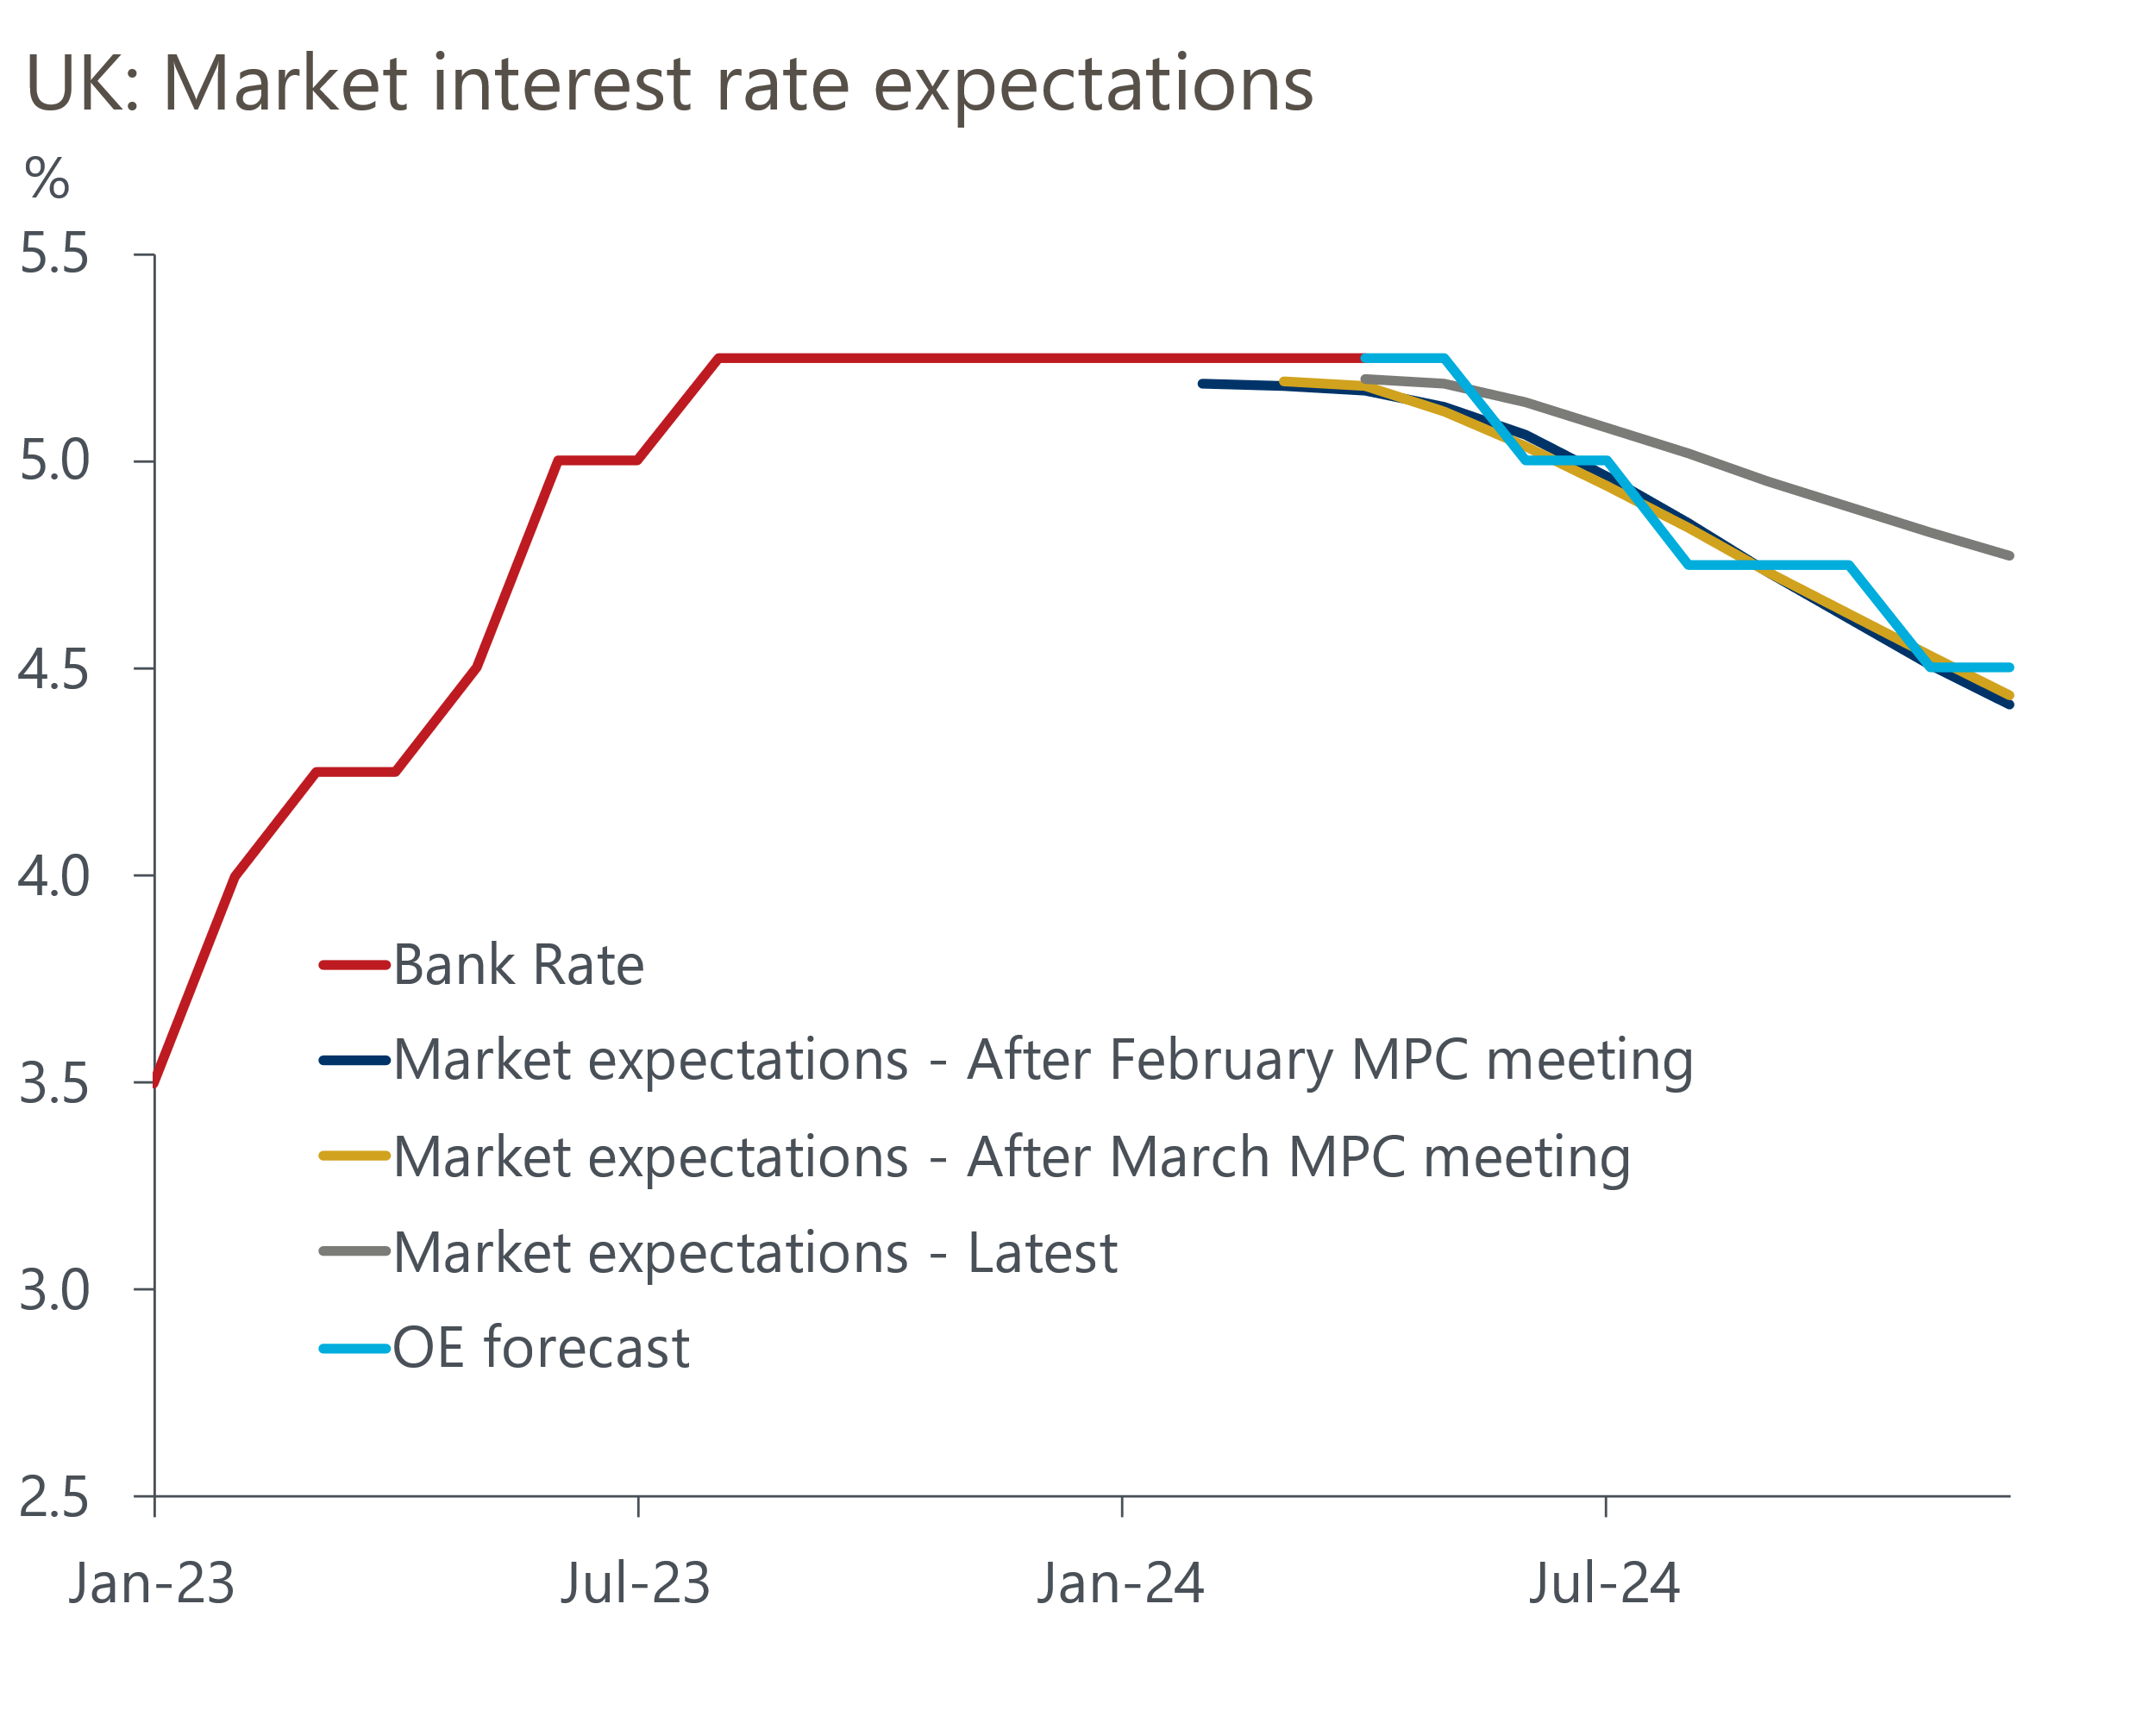
Sources: Oxford Economics, Haver Analytics
We view the recent market moves as excessive. In part, they reflect markets making too strong a connection between the UK and US. Speaking this week at the International Institute of Finance conference, BoE Governor Andrew Bailey appeared content with the idea that the Bank can cut rates ahead of the Fed, stating that "there is more demand-led inflation in the US and the UK faces less inflation risk".
Certainly the modest upside surprises in this week's pay and inflation data mean the chances of a May rate cut are now virtually zero. But while a June rate cut appears less likely than it did, we don't see the week's data as a barrier to a policy pivot that month. The MPC will receive two additional sets of labour market and inflation releases between its May and June meetings, including the key April data. If we're right that the annual indexation in many services prices will be much lower this year, this should provide the committee with some reassurance over the stickiness of core inflation. Similarly, if pay growth slows in line with our nowcast, this will reduce concerns about the strength of second-round effects. But even if the MPC doesn't cut in June, we still think a move at some point in the summer is the most likely scenario.
Lower inflation and the eventual passthrough of rate cuts should be positive for the retail sector. The ONS reported that retail sales volumes were flat in March, which left sales up 1.9% over Q1 as a whole, after a 1% fall in Q4 2023. We are now clearly past the trough in terms of consumer demand and activity, with the benefits of the recovery in real incomes beginning to emerge. So provided consumers move away from the very cautious behaviour they exhibited last year, a decent uplift in spending is in prospect.

The week ahead
A quieter week is in prospect, starting with the publication of March's public finance data. Given government borrowing in March 2023 was still inflated by energy support to households and businesses, the deficit in March 2024 should have fallen again in y/y terms. Therefore, we forecast public sector net borrowing (excluding banks) was £8.4bn in March. This implies borrowing over the full fiscal year 2023-2024 came in at £118.6bn, slightly above the OBR's March forecast of £114.1bn.
March's S&P Global surveys suggested the gap in sectoral performance narrowed significantly compared with previous months. If the survey's forward-looking balances are anything to go by, the gap is likely to shrink again in April. The services survey reported that new orders sank to a four-month low, so we think the flash services PMI may have slipped slightly to 52.9 in April. In contrast, higher business optimism amongst goods producers and a return to growth in new orders, means we expect April's flash manufacturing PMI to have edged up to 50.6. This would leave the composite PMI at around 52.6.
Table 1: Week ahead calendar
Date | Events | Period | Measure | Unit | Previous | Forecast
Apr 23 | Public finances | Mar | PSNB ex | £bn | 8.4 | 11.8
Apr 23 | S&P Global/CIPS manufacturing | Apr | PMI | % bal | 50.3 | 50.6
Apr 23 | S&P Global/CIPS services | Apr | PMI | % bal | 53.1 | 52.9
Apr 23 | S&P Global/CIPS composite | Apr | PMI | % bal | 52.8 | 52.6
Source: Oxford Economics

Key forecasts
Table 2: UK forecast overview
(Annual percentage changes unless specified)
 | 2022 | 2023 | 2024 | 2025 | 2026 | 2027
GDP | 4.3 | 0.1 | 0.6 | 2.0 | 2.0 | 1.6
Private consumption | 4.8 | 0.2 | 1.0 | 2.6 | 2.2 | 1.6
Fixed investment | 8.0 | 2.2 | -2.8 | 1.1 | 2.8 | 2.1
Government consumption | 2.3 | 0.5 | 4.1 | 2.2 | 1.5 | 1.5
Exports of goods and services | 9.0 | -0.5 | -0.8 | 2.8 | 2.4 | 1.7
Imports of goods and services | 14.6 | -1.5 | 1.5 | 3.9 | 2.9 | 1.9
Industrial Production | -3.5 | -0.3 | 0.1 | 0.9 | 1.5 | 1.2
Consumer prices | 9.1 | 7.3 | 2.3 | 2.2 | 2.3 | 2.2
Unemployment rate (%) | 3.9 | 4.0 | 4.2 | 4.0 | 3.8 | 3.8
Current a/c balance (% of GDP) | -3.1 | -3.3 | -2.9 | -3.0 | -3.0 | -3.0
Government balance (% of GDP) | 4.4 | 5.0 | 3.5 | 3.1 | 2.3 | 1.5
Cen. bank policy rate (%, EOP) | 3.50 | 5.25 | 4.50 | 3.50 | 2.50 | 2.00
10yr govt. bond yield (%, EOP) | 3.67 | 3.54 | 3.87 | 3.51 | 3.08 | 2.85
Exchange rate (US$ per £, EOP) | 1.20 | 1.27 | 1.27 | 1.27 | 1.28 | 1.30
Exchange rate (euro per £, EOP) | 1.13 | 1.15 | 1.16 | 1.15 | 1.15 | 1.14
Source: Oxford Economics
Table 3: Quarterly forecasts for the UK
 | 2024 |  |  |  | 2025
 | Q1 | Q2 | Q3 | Q4 | Q1 | Q2 | Q3 | Q4
GDP (% year) | 0.0 | 0.2 | 0.7 | 1.6 | 1.7 | 2.0 | 2.1 | 2.2
CPI inflation (% year) | 3.5 | 1.9 | 1.8 | 2.1 | 2.0 | 2.0 | 2.3 | 2.3
Bank Rate (%, EOP) | 5.25 | 5.00 | 4.75 | 4.50 | 4.25 | 4.00 | 3.75 | 3.50
10yr gilt yield (%, EOP) | 3.95 | 4.10 | 3.97 | 3.87 | 3.79 | 3.71 | 3.62 | 3.51
US$ per £ (EOP) | 1.26 | 1.27 | 1.27 | 1.27 | 1.27 | 1.27 | 1.27 | 1.27
Euro per £ (EOP) | 1.17 | 1.16 | 1.16 | 1.16 | 1.16 | 1.16 | 1.15 | 1.15
Source: Oxford Economics

Latest Country Economic Forecast:
March 18, 2024

Recent publications

Data Insights
Flat sales in March caps off a strong Q1 for retailers
Inflation surprised on the upside in March
Pay growth remains resilient, reducing chances of a May cut
GDP rose in February and remains on course to rebound in Q1
Lower services PMI still points to healthy activity growth in Q1

Research Briefings
What the Bernanke review says about the state of forecasting
Inflation to dip below 2% in H2 2024, but rise slightly in 2025
The MPC and rates - preparing to descend Table Mountain
MPC remains on track for a June rate cut
MPC preview – Caution is the name of the game

Contacts

Oxford Economics' UK team
- Andrew Goodwin - Chief UK Economist - agoodwin@oxfordeconomics.com
- Edward Allenby - UK Economist - eallenby@oxfordeconomics.com

